
AURA
AURA: Real time AI assistant using Esp32 Arduino

Presented to the
College of Arts, Sciences and Education
Lapu-lapu St., Brgy. Poblacion, Tacurong City, Sultan Kudarat 9800

In Partial Fulfillment
of the Requirements for the Course
CPEE Cognate Track Course 1

Submitted by:
Romero, Jolo M.
Maniago, Christian Harvey D.

Submitted to:
ENGR. JOSETH ANGELO A. BIDDING, CcpE

1. Introduction
The Project Identity: Artificial Intelligence (AI) has become an essential part of modern technology, providing users with instant access to information, automation, and intelligent assistance. AI-powered virtual assistants such as Siri, Google Assistant, and Alexa have transformed how people interact with devices by enabling voice-based communication and real-time responses (OpenAI, 2024). However, many AI assistant systems require expensive hardware and internet-dependent platforms, limiting accessibility for students and small-scale users.
Core Microcontroller: AURA: A Real-Time AI Assistant Using ESP32 and Arduino for Smart Interaction is an intelligent embedded system designed to provide users with real-time information and assistance through a text-based interface. The system utilizes an ESP32 development board as its core microcontroller, serving as the brain of the device by processing user inputs, communicating with AI services, and controlling all system operations. The primary input components include a keypad or push-button module that allows users to enter commands and requests, while the main output components consist of an OLED or LCD display that presents AI-generated responses and system information. The device also uses Wi-Fi connectivity to communicate with online AI platforms and retrieve accurate responses in real time. Once powered on, the system accepts user requests, processes them through an AI service, and displays relevant information, providing a smart, efficient, and interactive assistant for everyday use.
Primary Inputs and Outputs: The primary input of the system is the ESP32's Wi-Fi module, which receives user requests and data from external AI services through an internet connection. Additional inputs may include a keypad, push buttons, or a web-based interface used to submit commands. The primary output components are the OLED/LCD display, which presents AI-generated responses and system information, and indicator LEDs that provide status notifications to the user.
The Ultimate Objective: Once fully powered on and connected to the internet, the device processes user requests in real time, communicates with AI services, and provides accurate responses through its display, enabling users to access information and assistance quickly and efficiently.
2. Background of the Proposed Project
The Problem Statement: In today's digital environment, students, teachers, and office personnel often need quick access to information, schedules, reminders, and academic resources. However, obtaining this information usually requires manually searching through websites, documents, or applications, which can be time-consuming and inefficient. Many users also rely on multiple platforms to find answers, resulting in delays and reduced productivity, especially when immediate information is needed.
Current information retrieval methods often require continuous internet browsing and manual data entry. This process can be inconvenient in educational and workplace settings where users need fast and reliable access to information. Additionally, commercial AI assistant devices are often expensive and may not be accessible to students who want to explore artificial intelligence and embedded systems technology. The lack of affordable and customizable AI-based assistance systems limits opportunities for learning and innovation.
To address these challenges, the proposed Real-Time AI Assistant Using ESP32 provides a low-cost and efficient solution capable of processing user requests and displaying AI-generated responses in real time. By automating information retrieval and integrating artificial intelligence with embedded systems technology, the project reduces the need for manual searching, improves accessibility to information, and enhances user productivity in educational and everyday environments.
Target Users: The primary users affected by this problem are students, teachers, researchers, and office personnel who frequently require quick access to information for academic, professional, and personal tasks. These individuals often spend significant time searching through websites, documents, and online resources to find the information they need, which can reduce productivity and efficiency. In educational settings, students may experience delays in completing assignments or research activities due to the time required to gather accurate information.
Additionally, individuals who have limited access to advanced technology or commercial AI assistant devices are negatively impacted. Many existing AI-powered systems can be costly and may not be affordable for students and small organizations. By providing an accessible and low-cost AI assistant using ESP32 technology, the proposed project aims to support users who need fast, reliable, and convenient access to information while promoting the practical application of artificial intelligence and embedded systems.
The Proposed Automation: The Real-Time AI Assistant using ESP32 (Arduino-based) improves efficiency and user experience by automating tasks that are normally done manually. It processes inputs and produces responses in real time, reducing the time needed for searching, switching devices, or performing repeated actions. As a result, users receive faster and more convenient responses.
The system also increases accuracy and reduces human error by following programmed logic and AI-based processing. This ensures more consistent and reliable results, especially for repetitive tasks that are usually prone to mistakes when done manually.
Benefits and Significance: In addition, the AI Assistant setup improves stability and resource efficiency by ensuring strong and uninterrupted communication between components. This reduces signal loss, system failures, and downtime, making the assistant more reliable for continuous use. Overall, it enhances productivity by saving time, reducing errors, and simplifying user interaction.
3. Schematic Diagram & Hardware Specifications
Figure 1 shows the complete wiring diagram of the Real-Time AI Assistant Using ESP32 Arduino. The system consists of an ESP32 Development Board as the main controller, an ILI9341 TFT display for graphical output, a joystick module for menu navigation, a microphone module for voice input, and a speaker module for audio output. All components are connected according to the ESP32's voltage and communication requirements to ensure stable and reliable operation.

Component Name | Component Pin | Arduino Pin | Connection Purpose / Signal Type
ILI9341 TFT Display | VCC | 3V3 | Power Supply (+3.3V)
ILI9341 TFT Display | GND | GND | Ground
ILI9341 TFT Display | CS | GPIO16 | SPI Chip Select
ILI9341 TFT Display | RST | GPIO4 | Display Reset
ILI9341 TFT Display | DC | GPIO2 | Data/Command Control
ILI9341 TFT Display | MOSI | GPIO23 | SPI Data (ESP32 → TFT)
ILI9341 TFT Display | SCK | GPIO18 | SPI Clock
ILI9341 TFT Display | LED | 3V3 | Backlight Power
ILI9341 TFT Display | MISO | GPIO19 | SPI Data (TFT → ESP32)
Joystick Module | VCC | 3V3 | Power Supply (+3.3V)
Joystick Module | VERT | GPIO34 | Vertical Analog Input (Y-axis)
Joystick Module | HORZ | GPIO35 | Horizontal Analog Input (X-axis)
Joystick Module | SEL | GPIO32 | Push Button Digital Input
Joystick Module | GND | GND | Ground

4. Source Code Repository & Logic Design

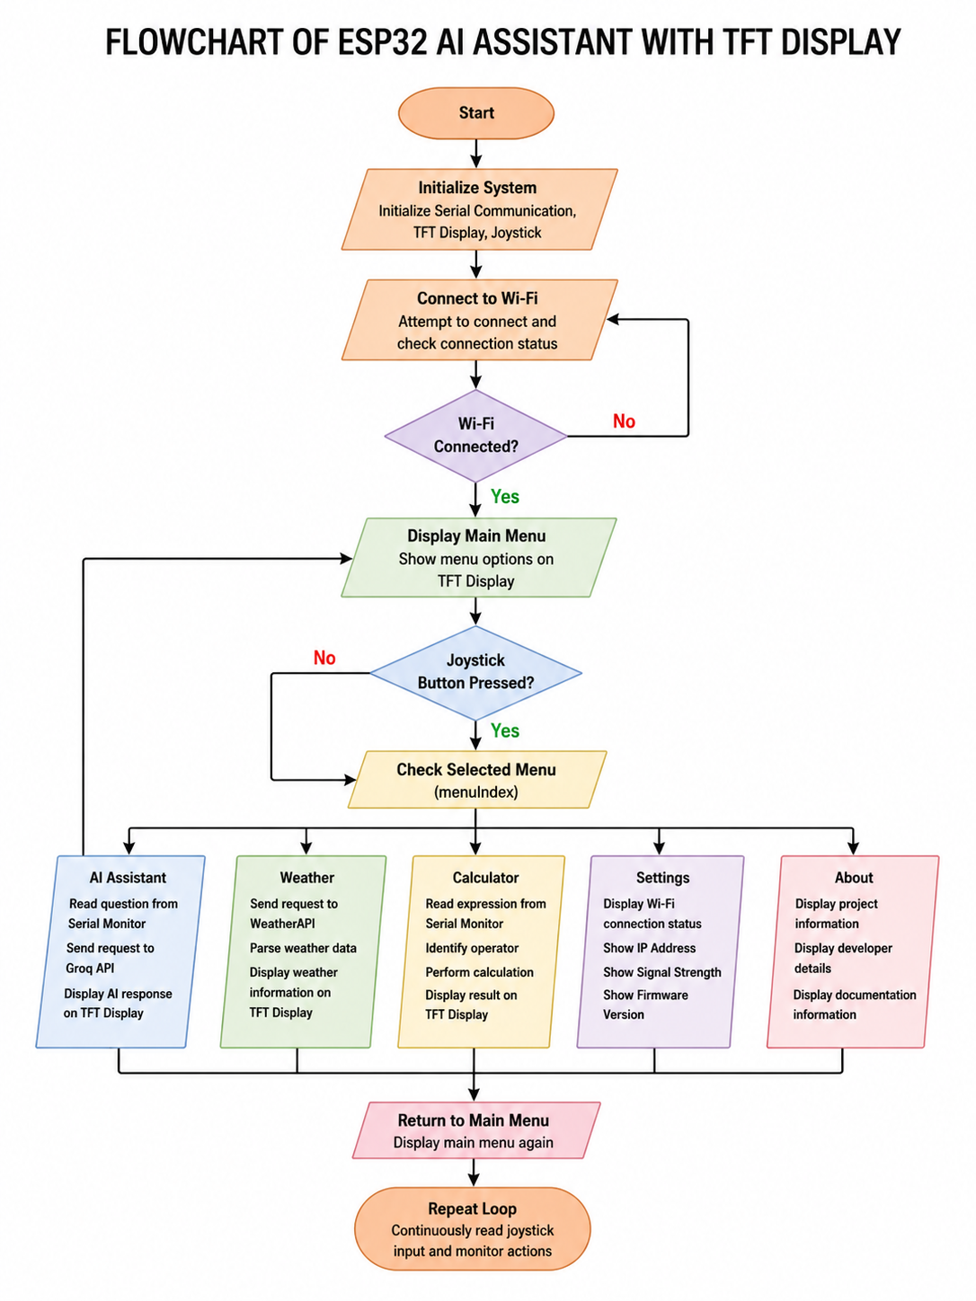


The ESP32 AI Assistant begins execution by initializing the TFT display, joystick module, serial communication, and Wi-Fi connection. During startup, the program continuously checks the Wi-Fi connection status and waits until a successful connection is established. Once connected, the main menu is displayed on the TFT screen.
The joystick serves as the primary input device. The ESP32 continuously reads the analog values from the joystick's Y-axis using analogRead(JOY_Y). If the reading is below 1000, the program interprets the action as moving down through the menu options. If the reading is above 3000, the program interprets the action as moving up through the menu. The currently selected menu item is highlighted on the display.
When the joystick button is pressed (digitalRead(JOY_SW) == LOW), the ESP32 checks the current menu selection using a switch-case statement and activates the corresponding feature. For the AI Assistant, the system reads a question entered through the Serial Monitor, sends the request to the Groq API, receives the response, and displays the answer on the TFT screen. For the Weather feature, the ESP32 sends a request to the WeatherAPI service, extracts the city name, temperature, humidity, and weather condition, then displays the information on the screen. For the Calculator feature, the system reads a mathematical expression from the Serial Monitor, identifies the operator, performs the calculation, and displays the result.
Throughout execution, conditional statements continuously monitor joystick movements, button presses, Wi-Fi connectivity, and API responses. Based on these conditions, the ESP32 changes the state of the display, updates menu selections, executes functions, and returns to the main menu when requested by the user.
5. Student Project Portfolio

Name: ROMERO JOLO M.

Course: COMPUTER ENGINEERING

Project Title: Real time AI assistant using esp32 arduino

Date: 06/15/26

Project Role and Responsibilities

During this project, I was primarily responsible for the software development of the ESP32 AI Assistant system. My responsibilities included designing the program structure, developing the menu-driven user interface, implementing AI and weather API integration, creating the calculator functionality, and managing communication between the ESP32 and the TFT display. I also performed software testing, debugging, code optimization, and documentation to ensure that all features operated correctly and reliably. Through these tasks, I contributed to the successful development and implementation of the project's software components



Name: MANIAGO, CHRISTIAN HARVEY

Course: COMPUTER ENGINEERINg

Project Title: ESP32 AI Assistant with TFT Display

Date: 06/16/26
Project Role and Responsibilities
I contributed to the development of the project paper by writing and editing sections such as the introduction, background of the study, hardware specifications, and project documentation. I ensured that the information presented was accurate, well-organized, and aligned with the project objectives. Through these tasks, I helped establish a strong technical foundation for the project and supported the successful completion of its documentation and hardware planning.
6. Individual Technical Reflections
ROMERO JOLO M
1. What was the single most difficult technical obstacle, software bug, or hardware failure you personally encountered during this course project?
The single most difficult technical obstacle I encountered during this project was integrating the ESP32 with the Groq AI API and ensuring that the responses were displayed correctly on the ILI9341 TFT screen. While the Wi-Fi connection was established successfully, there were instances where API requests failed, returned errors, or produced data that was not displayed properly. Identifying whether the problem originated from the network connection, API communication, or display logic was particularly challenging. Resolving these issues required careful testing of both the hardware and software components.
2. What steps, debugging methodologies, or diagnostic tools did you use to isolate and fix that specific problem?
To isolate and fix the issue, I used the Arduino Serial Monitor to monitor Wi-Fi status messages, API responses, and error codes. I tested each subsystem individually, including the TFT display, joystick inputs, Wi-Fi connection, and API requests, before integrating them into the complete project. By analyzing serial outputs, validating JSON responses, and checking the program flow step by step, I was able to identify the source of errors and implement the necessary corrections. This systematic debugging approach significantly improved the reliability of the system.
3. Based on this project, what is the most critical concept you learned regarding embedded systems design, circuit safety, or hardware-software interaction?
Based on this project, the most critical concept I learned is the importance of effective hardware-software interaction in embedded systems. Even when the hardware is connected correctly, reliable software logic and communication protocols are necessary to ensure proper system operation. I also learned that systematic debugging, careful testing, and incremental integration are essential practices for developing safe, stable, and dependable embedded applications. These lessons will help me develop more efficient and reliable embedded systems in future projects.

MANIAGO, CHRISTIAN HARVEY D.
1. What was the single most difficult technical obstacle, software bug, or hardware failure you personally encountered during this course project?
The most difficult challenge I encountered during this project was making sure that all the information in our paper was accurate and complete. Since I was responsible for researching the hardware components, I had to carefully understand how each part of the system worked and how they were connected. It was sometimes challenging to find reliable information and ensure that the details in the documentation matched the actual design of the project.
2. What steps, debugging methodologies, or diagnostic tools did you use to isolate and fix that specific problem?
To solve this problem, I reviewed datasheets, online references, and technical articles about the ESP32 and other hardware components used in the system. I also discussed the hardware specifications with my groupmate to verify the information and double-checked the wiring connections and project details before including them in the paper. This helped me ensure that the documentation was accurate and well-organized.
3. Based on this project, what is the most critical concept you learned regarding embedded systems design, circuit safety, or hardware-software interaction?
Through this project, I learned that proper research and documentation are just as important as building the actual system. Understanding the hardware components and how they interact with the software helps prevent errors and makes the project easier to develop and troubleshoot. I also realized that clear and accurate documentation is essential for creating a successful and reliable embedded system.

